Olubukola Kukoyi
MS Anna Devarakonda
ITAI 2372
19th April 2025
Leveraging Artificial General Intelligence (AGI) in healthcare
Introduction
Artificial General Intelligence (AGI) is often described as the next big leap in technology, imagine a computer system that can think, learn, and solve problems as flexibly as a human being. While today’s AI is impressive, it’s usually limited to specific tasks, like recognizing faces in photos or crunching numbers in spreadsheets. AGI could reason, adapt, and tackle a wide variety of challenges, just like we do. Artificial General Intelligence (AGI) represents a leap beyond narrow AI, which is designed for specific tasks like image recognition or language translation. AGI aims to replicate human-like cognitive abilities, enabling it to learn, reason, and adapt across diverse challenges without being limited to predefined functions. In healthcare, where complexity and human stakes are high, AGI’s potential to transform diagnostics, treatment, and patient care is profound. This paper explores how AGI could address critical challenges in the healthcare industry, proposing innovative applications while weighing benefits against ethical risks.
Industry Analysis
The healthcare industry plays a crucial role in maintaining global health, but it faces some serious challenges. The cost of healthcare is becoming increasingly difficult to manage, with U.S. spending hitting $4.5 trillion in 2022 alone. This surge in costs puts immense pressure on both patients and healthcare systems. Workforce shortages, especially among nurses and primary care providers, worsen the issue of healthcare access, making rural communities particularly vulnerable. Each year, diagnostic mistakes impact around 12 million Americans and are responsible for approximately 10% of patient deaths (Newman-Toker et al., 2019). Moreover, routine administrative tasks like billing and maintaining patient records take up valuable resources, reducing the time available for patient-focused care.
Currently, the application of AI in healthcare has shown promise but remains limited. For example, machine learning algorithms are quite effective in diagnostic imaging, such as identifying cancers from radiology scans, sometimes exceeding 90% accuracy rates (Esteva et al., 2017). Predictive analytics tools have also been useful in managing patient admissions and discharges, while AI-powered chatbots make appointment scheduling easier. Nevertheless, these AI solutions typically focus on very specific tasks and can't easily adapt to new or more complex situations without additional training. A system designed to detect lung cancer, for instance, won't be able to shift seamlessly to analyze heart conditions or consider broader social factors
impacting patient health. These limitations highlight the potential benefits of developing Artificial General Intelligence (AGI), which could offer more versatile and comprehensive cognitive abilities.

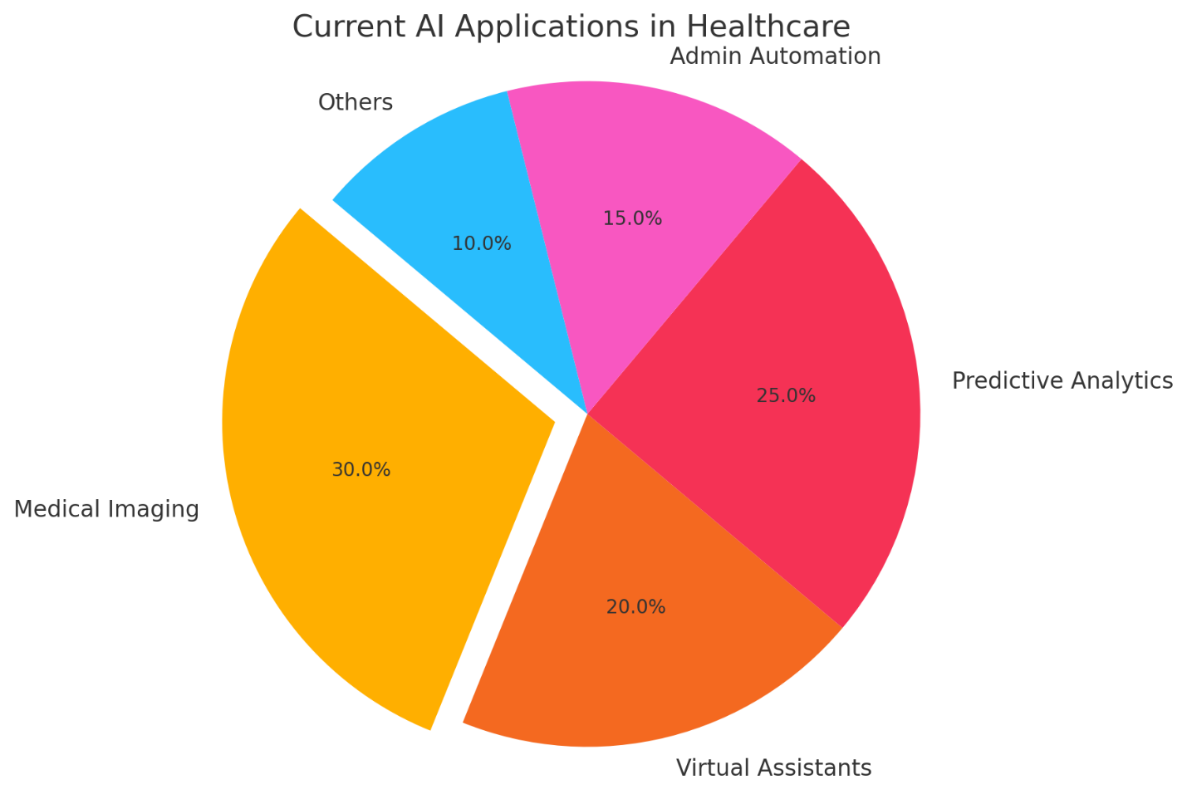
Figure 1: Distribution of AI Applications in Healthcare
As illustrated in Figure 1, AI applications are spread across medical imaging, virtual assistants, predictive analytics, and more. However, these systems remain narrow in function, requiring human oversight and integration limitations that AGI could potentially overcome.
AGI Application Proposal
Definition of AGI
AGI stands apart from narrow AI because of its capability to handle any intellectual task that humans can manage, from solving abstract problems to learning new areas without needing significant reprogramming. Unlike traditional AI, which works within fixed limits, AGI can integrate knowledge from multiple fields, adjust to new situations, and make informed decisions even in uncertain conditions. In healthcare, these qualities enable AGI to address complex issues that demand both precise technical skills and nuanced, human-like decision-making.
- How AGI Could Transform Healthcare
Smarter, Personalized Medicine
Imagine a system that pieces together your full health story genetics, daily habits, even your neighborhood’s air quality to craft treatments as unique as you are. AGI could spot rare conditions by connecting dots humans might miss, like linking a child’s unusual fatigue to a genetic disorder that only appears in medical journals from halfway across the world. Treatment plans wouldn’t just consider your test results but also your work schedule, cultural beliefs, and budget, making it easier to stick to the plan and stay healthy.
- Emergency Response supercharged
During a hurricane or outbreak, AGI could act like a global health conductor. Picture it is rerouting medical supplies to flooded towns before roads collapse, predicting which neighborhoods will need the most vaccines next week, or helping exhausted ER teams prioritize patients all while learning from every new piece of data. Unlike today’s tools that focus on single tasks, AGI could juggle logistics, research, and patient care simultaneously, adapting as crises evolve.
- Cutting the Red Tape
AGI could take over the paperwork maze that drives healthcare workers crazy like untangling insurance claims that get denied for baffling reasons or ensuring hospitals comply with ever-changing regulations. This isn’t just about speed; it’s about freeing nurses to comfort anxious families instead of battling spreadsheets. Clinics could redirect the time and money saved toward hiring more staff or upgrading equipment.
Why This Matters
- Speed Meets Precision: What takes days now like diagnosing a mysterious fever could happen over a coffee break. Faster answers mean treatments start before conditions worsen.
- Breakthroughs on Fast-Forward: AGI could scan millions of failed drug trials to find hidden gems, turning “dead-end” research into life-saving treatments in years, not decades.
- Care Where It’s Needed Most: A grandmother in a remote village could video-chat with an AGI assistant that speaks her dialect, reviews her health history, and connects her to a diabetes specialist in the nearest city all without leaving home.
The Risks We Can’t Ignore
- Your Data’s Safety: AGI needs deep access to your health secrets to work its magic. Without ironclad protection, this could become a hacker’s goldmine.
- Fairness First: If trained mostly on data from wealthy cities, AGI might overlook health issues unique to rural or marginalized communities, making existing disparities worse.
- Jobs in Transition: While AGI handles paperwork, we’ll need to retrain administrative staff for roles that require human warmth like guiding patients through tough diagnoses.
- Who’s Responsible? If an AGI system misdiagnoses a patient, is it the software company’s fault? The hospitals? Clear rules will be needed to prevent finger-pointing when lives are on the line.
In Everyday Terms
Think of AGI as the ultimate healthcare sidekick one that never sleeps, remembers every medical textbook ever written, but still lets human doctors make the final call. It’s not about replacing the nurse’s comforting hand on your shoulder but ensuring that hand has the best tools possible to help you heal.
Final Thoughts: A Future Where Tech Meets Humanity
AGI could be healthcare’s game-changer tackling misdiagnoses, cutting through red tape, and bringing expert care to doorsteps worldwide. Imagine fewer errors, lower costs, and clinics where everyone gets the same high-quality attention, whether they’re in a skyscraper or a village. But this isn’t just about smarter machines; it’s about building guardrails to protect privacy, root out biases, and ensure no one’s left behind as jobs evolve.
The road ahead? Doctors, tech teams, and lawmakers need to work side-by-side, keeping patient trust at the center. AGI shouldn’t replace the human touch it should give healers superpowers, letting them focus on what matters most: the quiet reassurance of a handhold, the art of listening, and the wisdom to know when a screen can’t replace a smile. The goal? Technology that doesn’t just treat illness, but nurtures healing.
References
- Centers for Medicare & Medicaid Services (CMS). (2023). National health expenditure data. https://www.cms.gov
- DiMasi, J. A., Grabowski, H. G., & Hansen, R. W. (2016). Innovation in the pharmaceutical industry: New estimates of R&D costs. Journal of Health Economics, 47, 20–33.
- Esteva, A., Kuprel, B., Novoa, R. A., Ko, J., Swetter, S. M., Blau, H. M., & Thrun, S. (2017). Dermatologist-level classification of skin cancer with deep neural networks. Nature, 542(7639), 115–118.
- Health Resources and Services Administration (HRSA). (2023). Health workforce shortage areas. https://www.hrsa.gov
- Himmelstein, D. U., Jun, M., Busse, R., Chevreul, K., Geissler, A., Jeurissen, P., ... & Woolhandler, S. (2014). A comparison of hospital administrative costs in eight nations: US costs exceed all others by far. Health Affairs, 33(9), 1586–1594.
- Newman-Toker, D. E., Schaffer, A. C., Yu-Moe, C. W., Nassery, N., Saber Tehrani, A. S., Clemens, G. D., ... & Siegal, D. (2019). Serious misdiagnosis-related harms in malpractice claims: The “Big Three”–vascular events, infections, and cancers. Diagnosis, 6(3), 227–240.
- Jiang, F., Jiang, Y., Zhi, H., Dong, Y., Li, H., Ma, S., ... & Wang, Y. (2017). Artificial intelligence in healthcare: Past, present and future. Stroke and Vascular Neurology, 2(4), 230–243. https://doi.org/10.1136/svn-2017-000101

